VLAN WITH CISCO

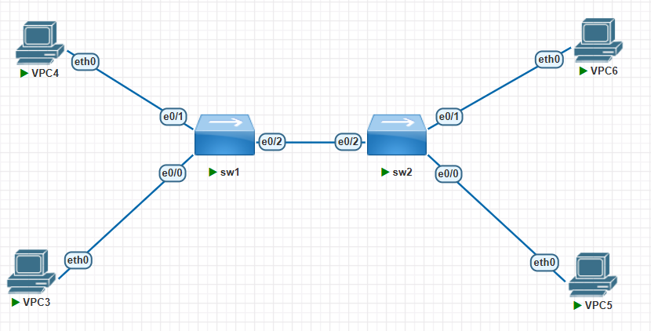

**1.konfigurasi sw1**

enable

conf t

vlan 10

name HR

vlan 20

name IT

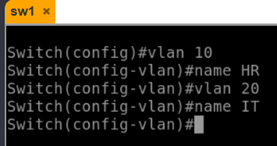

interface e0/0

switchport mode access

switchport access vlan 10

interface e0/1

switchport mode access

switchport access vlan 10

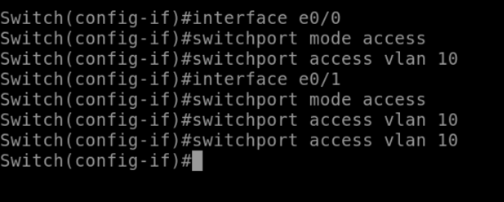

interface e0/2

switchport mode trunk

switchport trunk allowed vlan 10,20

end

wr

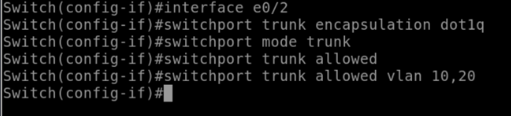

Tambahkan “switchport trunk encapsulation dot1q”jika saat mengetikkan “switchport mode trunk” terjadi invalid karena beberapa image iol l2 cisco **tidak bisa diubah manual.**

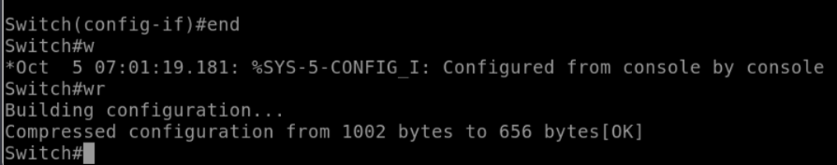

**2.konfigurasi sw2**

enable

conf t

vlan 10

name HR

vlan 20

name IT

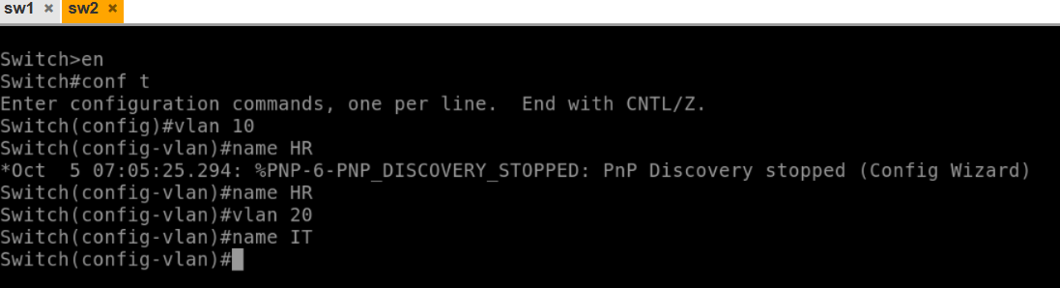

interface e0/0

switchport mode access

switchport access vlan 20

interface e0/1

switchport mode access

switchport access vlan 20

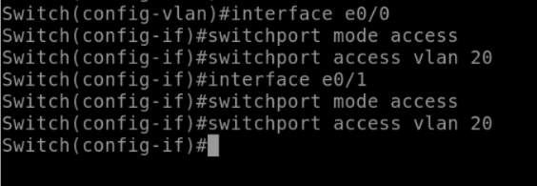

interface e0/2

switchport mode trunk

switchport trunk allowed vlan 10,20

end

wr

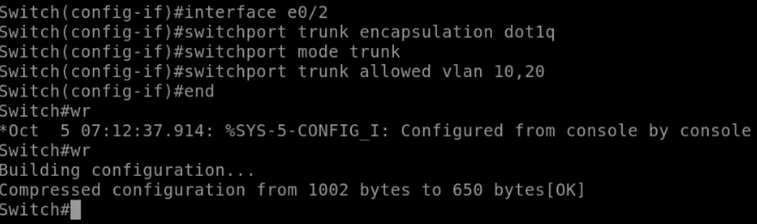

**3.Atur ip vpc 3,4,5,6 dan test ping ke sesama vlan**

(ping vpc 3 ke 4 dan sebaliknya)

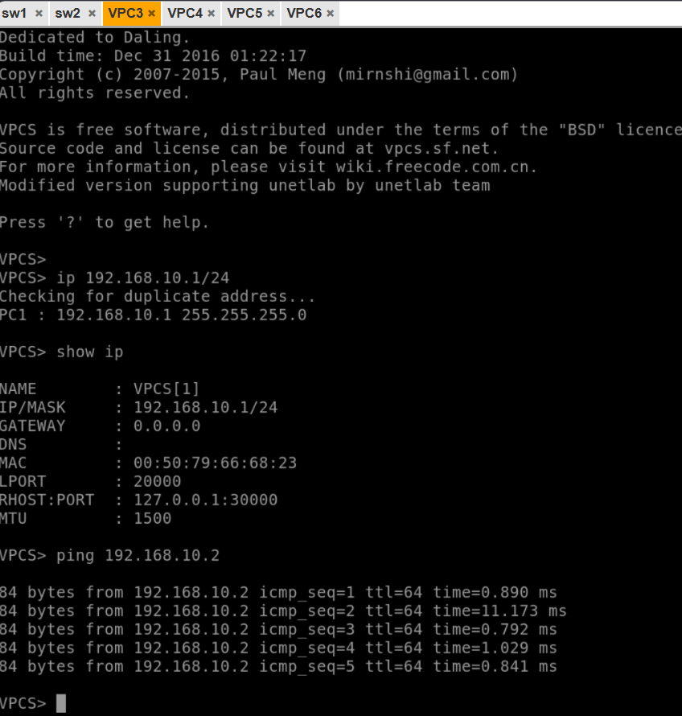

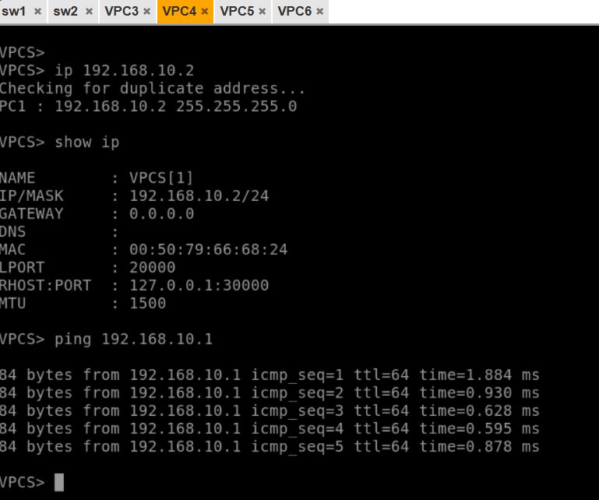

(ping vpc5 ke vpc6 dan sebaliknya)

